Project: Woodson Park Academy & YMCA-ELC
Week Ending: July 19th, 2019

THIS WEEK:
- Site contractor onsite began grading temp pond
- Georgia Power hauled off transformer
- COA watershed is installing new 8” water line off of Hollowell with no cost to this project – began testing

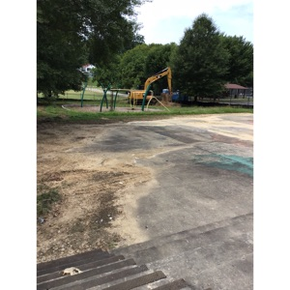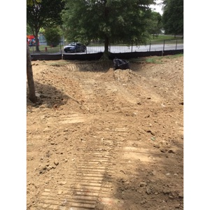

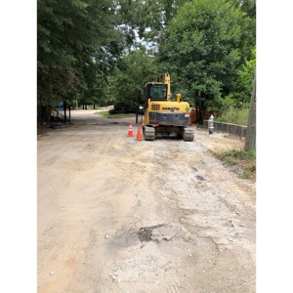

NEXT WEEK – July 22 thru July 26:
- Erosion control per LDP plans
- COA continues waterline
- Level construction to walk site looking at tires to remove
- Install web cam

PAYMENT STATUS:
- Gmp#1 $3,703,488.00
  - Paid to date amount $0.00
- GMP#2 $28,686,295.00
  - Paid to date amount $0.00

SCHEDULED DATE OF SUBSTANTIAL COMPLETION
- WPA – September 17, 2020
- YMCA-ELC - September 14, 2020

PREPARED BY:
- Matt Dauber, Carroll Daniel Construction Co.

